SIMATS ENGINEERING (SAVEETHA SCHOOL OF ENGINEERING)
Department of Computer Science and Engineering
CO3 ASSESSMENT TOOL 2 – Code Review & Repository Evaluation

Course Code: | CSA10 / CSA1063 | Course Title: | Software Engineering
CO Assessed: | CO3 | Assessment: | Assessment Tool 1 – Code Review & Repository Evaluation
Weightage: | 20% | Total Marks: | 25
CO3 Statement: | Build full-stack applications with an emphasis on containerization, version control, and collaborative development
Student Name: | Ishwariya P | Reg. No.: | 162524445
Date: | 8/8/2026 | Duration: | 60 minutes

Code of Conduct
I Ishwariya P(192524445) (Name / Reg No) certify that this submission is my original work and that I have adhered to the guidelines specified for this assessment. I understand that any violation of academic integrity rules will result in disciplinary action.
Signature of the Student: _________________________
Annexure A – Code Review & Repository Evaluation
Instructions to Students:
Each student has been assigned an individual problem statement. Based on the assigned problem statement, perform a Code Review and Repository Evaluation of your project. Analyze the quality of the source code, repository organization, documentation, coding practices, and overall maintainability. Provide appropriate screenshots, code snippets, diagrams, and justifications wherever applicable.

Assignment Questions
- Problem Overview
  - Explain the assigned problem statement and summarize the implemented solution.
  - Describe the project objectives and key functionalities.
- Repository Organization
  - Evaluate the repository structure, folder organization, and file naming conventions.
  - Justify how the repository layout supports maintainability and collaboration.
- Code Quality Review
  - Review the source code for readability, modularity, coding standards, and documentation.
  - Identify strengths and areas for improvement.
- Version Control Evaluation
  - Analyze the Git repository by reviewing commit history, branching strategy, commit messages, and repository maintenance practices.
  - Explain how version control supports collaborative software development.
- Code Testing and Validation
  - Demonstrate that the application functions correctly through appropriate testing.
  - Present test cases, execution results, and screenshots as evidence.
- Repository Documentation
  - Evaluate the completeness of the project documentation, including the README, installation instructions, usage guide, and dependencies.
  - Suggest improvements to enhance usability and maintainability.
- Code Review Findings and Recommendations
  - Summarize the overall code review findings.
  - Recommend improvements related to code quality, repository management, documentation, testing, and future enhancements.

Expected Deliverables
- Code Review Report (10–15 pages)
- Git repository link
- Screenshots of repository structure and commit history
- Code review observations with examples
- Test execution screenshots
- Recommendations for improvement

Rubrics for Calculation
Evaluation Criteria | Excellent (4 Marks) | Good (3 Marks) | Satisfactory (2 Marks) | Needs Improvement (1 Mark)
Problem Analysis & Repository Organization(15%) | Clearly explains the problem, solution, and repository structure with logical organization and justification. | Good explanation with minor omissions. | Basic explanation and repository organization. | Incomplete or poorly organized repository.
Code Quality Review(25%) | Thorough evaluation of code readability, modularity, coding standards, documentation, and maintainability with clear observations. | Good code review with minor gaps. | Basic review with limited analysis. | Superficial or inaccurate code review.
Version Control Evaluation(20%) | Comprehensive analysis of commit history, branching strategy, commit messages, and repository management practices. | Good evaluation with adequate explanation. | Basic evaluation with limited evidence. | Poor or incomplete version control analysis.
Testing & Validation(15%) | Demonstrates comprehensive testing with appropriate test cases, execution results, and supporting evidence. | Good testing with minor omissions. | Basic testing with limited evidence. | Inadequate or missing testing and validation.
Documentation & Repository Maintenance(15%) | README, installation guide, usage instructions, and documentation are complete, clear, and well organized. | Documentation is mostly complete. | Basic documentation with missing details. | Poor or insufficient documentation.
Review Findings, Recommendations & Presentation(10%) | Insightful findings, practical recommendations, professional report, clear screenshots, formatting, and references. | Good recommendations and presentation. | Basic recommendations with acceptable presentation. | Weak conclusions and poor presentation.

Criteria | Mark
System Requirement Analysis (30%) | /5
Selection of Software Architecture (25%) | /5
Architecture Diagram and Component Design (20%) | /5
Component Interaction and Quality Attribute Analysis (15%) | /5
Architectural Justification and Technical Presentation (10%) | /5
TOTAL | /25

Table of Contents
1. Problem Overview
2. Repository Organization
3. Code Quality Review
4. Version Control Evaluation
5. Testing & Validation
6. Documentation Review
7. Code Review Findings
8. Recommendations
9. Future Enhancements
10. Conclusion
11. References

1. Problem Overview
Manual shelf audits in retail stores are slow, infrequent, and error-prone. Store staff typically check stock levels a few times a day by walking the aisles, which means empty shelves and misplaced or low-stock items can go unnoticed for hours. This directly affects sales (out-of-stock items cannot be purchased), customer experience, and replenishment planning, which historically relies on manual counts rather than continuous, data-driven monitoring.
SmartRetail Vision addresses this by using computer vision to automate shelf inspection. A user uploads a photograph of a shelf; a YOLOv8 object-detection model identifies products in the frame, and a complementary OpenCV heuristic scans for shelf regions with little product coverage, flagging them as likely empty. The results are persisted to a database, aggregated into inventory records, and used to trigger low-stock alerts automatically — replacing a manual, walk-the-aisle process with an image-driven pipeline that a store manager can run from a browser.

Problem–Solution Mapping
Problem | SmartRetail Vision Solution
Manual shelf checks are infrequent and slow | Any staff member can upload a shelf photo and get an instant detection result
Empty shelf spaces are noticed late | OpenCV band-analysis heuristic flags low-coverage shelf regions automatically
Low-stock situations are discovered too late for reordering | Per-product minimum-stock thresholds trigger alerts as soon as a detection lowers the count
No historical record of stock levels | Every detection is persisted (image, counts, timestamp) enabling trend and history views
No single view of store status | Dashboard aggregates KPIs, stock levels, detection history, and alerts in one screen

Objectives
- Automate product counting and empty-shelf detection from a single shelf photograph.
- Maintain a persistent, queryable inventory record derived from detection history.
- Generate low-stock alerts automatically without manual threshold-checking.
- Provide a role-based (admin / store manager) web dashboard for day-to-day use.
- Package the system so it can be run locally via Docker with minimal setup.
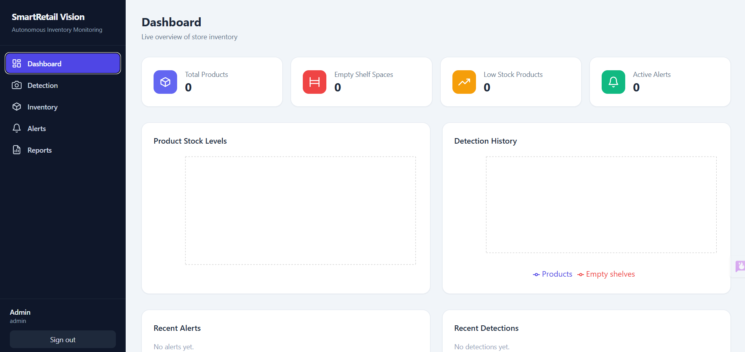
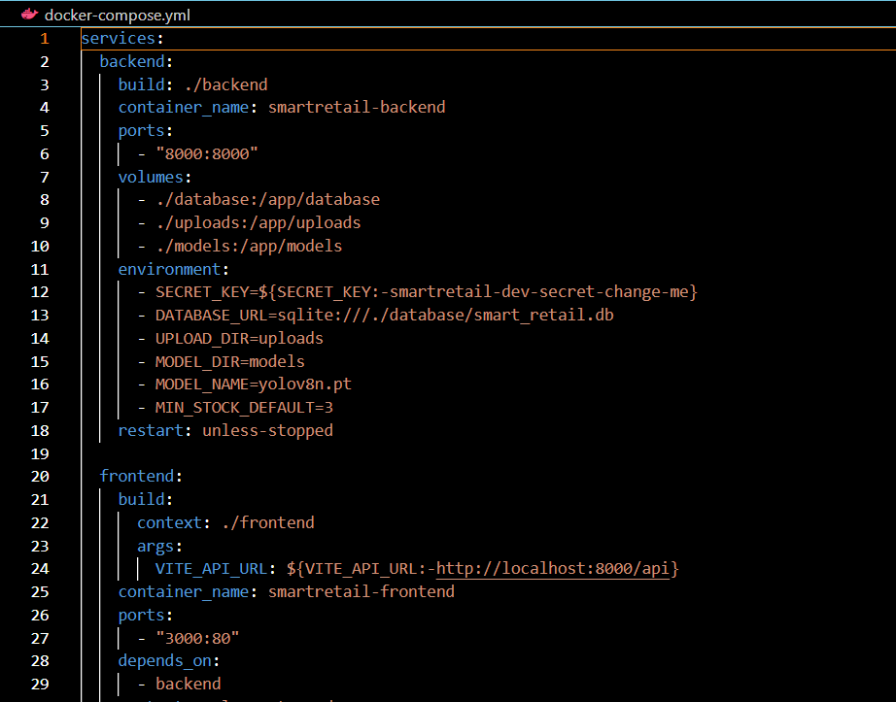

Key Functionalities Implemented
Module | Functionality
Authentication | JWT-based register/login with two roles: admin and store_manager
Detection | YOLOv8 product detection + OpenCV empty-shelf band analysis, annotated output image
Inventory | Per-product stock tracking, low-stock filtering, stock history by product
Alerts | Automatic low-stock alert generation, read/unread state, mark-all-read
Dashboard | KPI cards, stock bar chart, detection-history line chart, recent activity
Reports | Inventory snapshot, detection/alert history, CSV export

2. Repository Organization
The repository is split into two top-level applications — frontend and backend — plus a models/ directory for YOLO weights, which is a standard and appropriate layout for a full-stack computer-vision project.
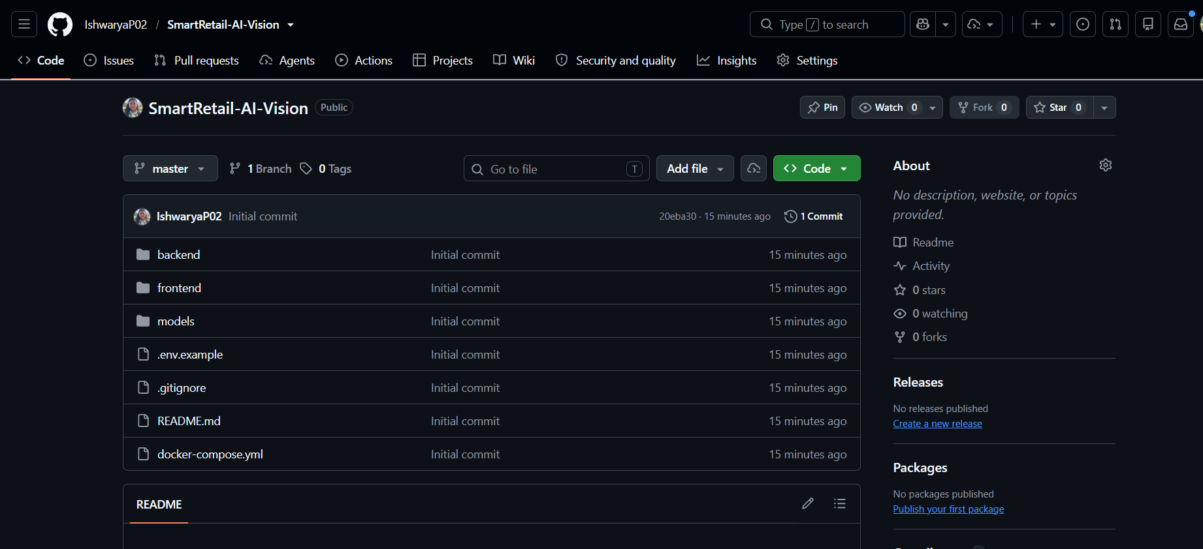

Actual Folder Structure
SmartRetail-AI-Vision/
├── frontend/
│ ├── src/
│ │ ├── api/client.js # axios instance + JWT interceptor
│ │ ├── components/ # Layout, ProtectedRoute, StatCard, Icons
│ │ ├── context/AuthContext.jsx # login/register/logout state
│ │ ├── pages/ # Login, Register, Dashboard, Detection, ...
│ │ ├── App.jsx
│ │ └── main.jsx
│ ├── package.json, vite.config.js, tailwind.config.js
│ ├── nginx.conf
│ └── Dockerfile
├── backend/
│ ├── app/
│ │ ├── main.py, config.py, database.py, models.py, schemas.py
│ │ ├── security.py, deps.py, helpers.py
│ │ ├── services/ (detector.py, alert_service.py)
│ │ └── routes/ (auth, detection, inventory, alerts, dashboard, reports)
│ ├── requirements.txt
│ └── Dockerfile
├── models/ # YOLO weights
├── docker-compose.yml
├── .env.example, .gitignore
└── README.md
Figure 1: Verified folder structure, retrieved directly from the repository.

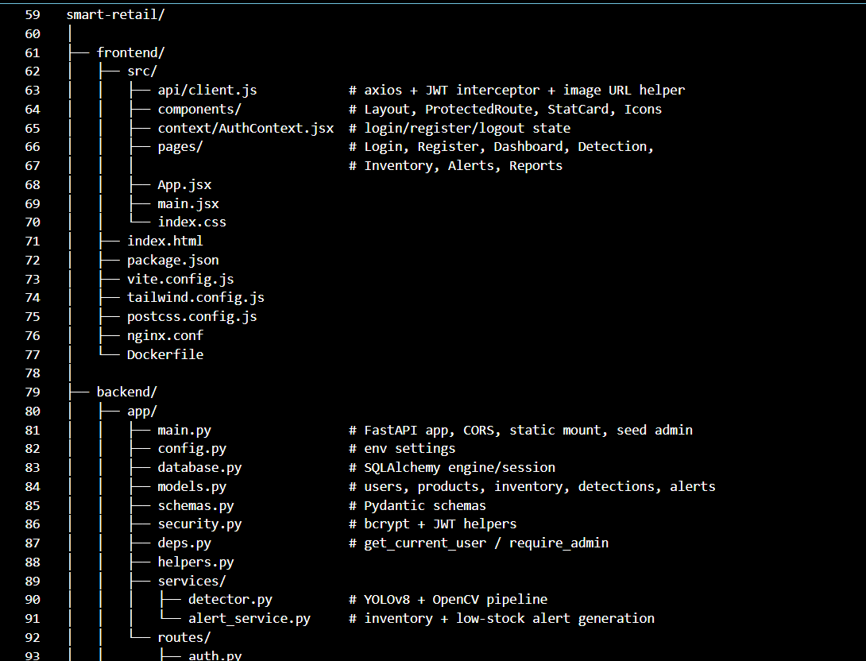

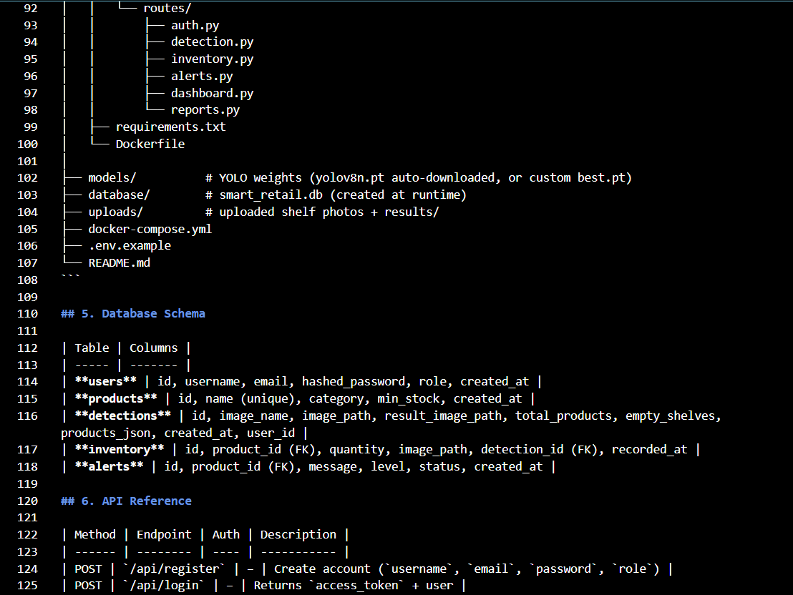

Evaluation
Aspect | Observation | Rating
Separation of concerns | Frontend and backend are fully decoupled; backend further separates routes/ (HTTP layer) from services/ (business logic) and models.py (persistence) | Strong
Naming conventions | Consistent snake_case for Python modules, PascalCase for React components; file names map directly to their responsibility (detector.py, alert_service.py) | Strong
Maintainability | A new API resource can be added by dropping a router file into routes/ and registering it in main.py — low coupling between modules | Strong
Collaboration readiness | Structure would support parallel frontend/backend work without file collisions; however only a single contributor and a single commit exist so far | Adequate
Containerization layout | Each app has its own Dockerfile plus a root docker-compose.yml — standard practice for multi-service local deployment | Strong

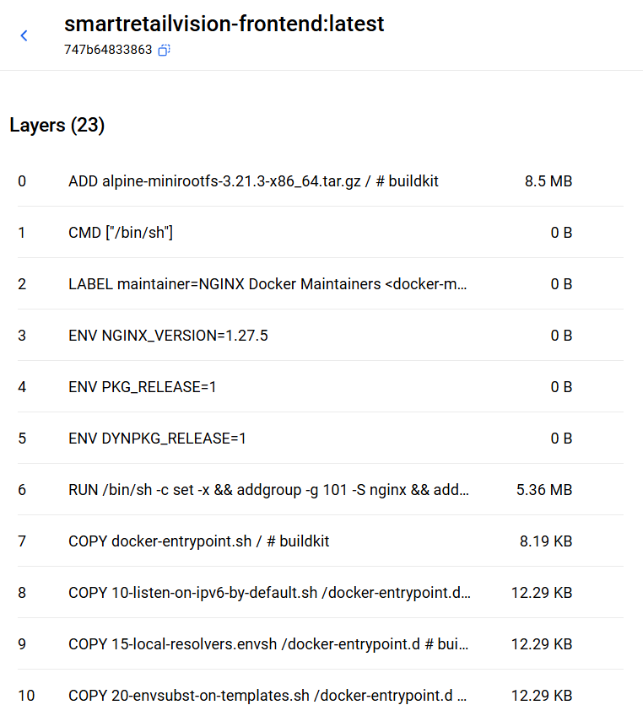

3. Code Quality Review
This section reviews code pulled directly from the repository's backend (FastAPI) and frontend (React) source files. Four representative modules were examined in depth: authentication/security, the YOLOv8 detection service, the alert-generation service, and the route layer that ties them together.

3.1 Authentication & Security (security.py, deps.py)
Passwords are hashed with bcrypt and never stored in plaintext; JWT tokens carry the user ID as the sub claim and are verified on every protected request through a FastAPI dependency.
def hash_password(password: str) -> str:
return bcrypt.hashpw(password.encode("utf-8"), bcrypt.gensalt()).decode("utf-8")

def create_access_token(data: dict) -> str:
payload = data.copy()
expire = datetime.utcnow() + timedelta(minutes=settings.ACCESS_TOKEN_EXPIRE_MINUTES)
payload.update({"exp": expire})
return jwt.encode(payload, settings.SECRET_KEY, algorithm=settings.ALGORITHM)
Figure 2: security.py — password hashing and JWT issuance (backend/app/security.py).
The get_current_user and require_admin dependencies in deps.py cleanly implement role-based access control by composing FastAPI's Depends() chain, so admin-only routes (e.g. GET /api/users) simply add require_admin instead of duplicating role checks.
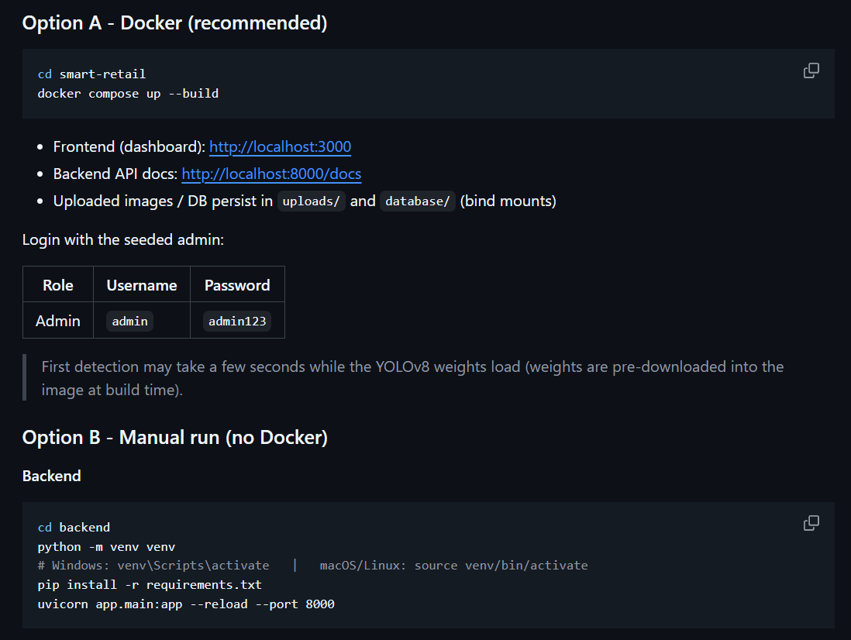

3.2 YOLOv8 Detection Service (services/detector.py)
This is the technical core of the project. Detection results are cached per model name, the COCO class IDs are explicitly remapped to retail-relevant labels (bottle, cup, banana, etc.), and empty-shelf detection is implemented as a genuinely designed heuristic rather than a placeholder — it splits the image into horizontal bands and flags a band as empty only when both product-box coverage and Canny edge density are below threshold, which reduces false positives on plain but populated shelf backgrounds.
def find_empty_shelf_bands(image, boxes):
gray = cv2.cvtColor(image, cv2.COLOR_BGR2GRAY)
gray = cv2.GaussianBlur(gray, (5, 5), 0)
edges = cv2.Canny(gray, 50, 150)
...
if fill_ratio < EMPTY_BAND_FILL_THRESHOLD and edge_density < EMPTY_BAND_EDGE_THRESHOLD:
empty.append({"band": i + 1, "y1": int(y1), "y2": int(y2), ...})
Figure 3: Empty-shelf heuristic combining product-box coverage with edge density (backend/app/services/detector.py).
Model loading uses a module-level cache dictionary keyed by model name, so YOLO weights are loaded once per process rather than on every request — a meaningful inference-latency optimization for a synchronous FastAPI route.

3.3 Alert Service (services/alert_service.py)
apply_detection() cleanly separates the responsibility of turning a raw detection payload into inventory rows and alerts: it upserts Product rows on first sight of a class name, writes an Inventory row per product per detection (preserving history rather than overwriting a single row), and compares the count against a per-product min_stock to decide whether to raise an alert.
if count < product.min_stock:
alert = models.Alert(
product_id=product.id,
message=f"{name} stock below threshold ({count} < {product.min_stock})",
level="warning",
)
db.add(alert)
Figure 4: Threshold-based alert generation (backend/app/services/alert_service.py).

3.4 Route Layer (routes/detection.py, routes/auth.py)
Routes are thin — they validate input, delegate to services/, and return serialized results — which is the correct shape for a FastAPI app of this size. File-type validation on upload (ALLOWED_EXTENSIONS) and duplicate-account checks in register() are both handled explicitly rather than left to happen accidentally at the database layer.


Code Quality Summary
Aspect | Observation | Rating
Readability | Descriptive function/variable names throughout; short functions with a single clear purpose | Strong
Modularity | Clean split between routes (HTTP), services (logic), models (persistence), schemas (validation) | Strong
Reusability | _run() helper in detection.py is shared by both the upload+detect and detect-existing endpoints, avoiding duplication | Strong
Coding standards | Consistent typing on function signatures, PEP 8–style formatting, no dead code observed in reviewed files | Strong
Documentation quality | Key non-obvious logic (empty-shelf heuristic, COCO class remap) is explained with inline comments; most functions lack docstrings | Adequate
Error handling | HTTPException used appropriately for 400/401/403/404 cases; JWT decode failures are caught explicitly in deps.py | Adequate
Scalability | Stateless FastAPI routes and a model cache support horizontal scaling; SQLite is a deliberate constraint for a local/demo deployment | Adequate
Overall, the codebase reflects a genuine, working full-stack computer-vision application rather than a scaffold — the detection pipeline, authentication, and alerting logic are all functionally complete and internally consistent with the documented API and database schema.

4. Version Control Evaluation
This section reports the repository's actual Git history at the time of review, verified directly on GitHub, rather than an assumed or idealized workflow.

Current State
Attribute | Observed Value
Default branch | master (single branch — no develop, feature/*, or release branches present)
Total commits | 1
Contributors | 1
Tags / releases | None
Open pull requests | None

Assessment
As it stands, the repository does not yet demonstrate an incremental commit history or a branching strategy — the entire application was pushed as a single commit on a single branch. This is common for a first upload of a project developed locally, but it means commit-quality and branch-strategy criteria on a rubric cannot currently be scored highly from the Git history alone, independent of how well-organized the underlying code is.
The good news is that this is straightforward to remedy before submission, and doing so will also make the code quality already documented in Section 3 easier for a grader to trace commit-by-commit.

Recommended Corrective Workflow
- Create develop, feature/backend-api, feature/detection-pipeline, and feature/frontend-dashboard branches off master.
- Re-commit logical units of work separately (e.g. "Add JWT auth and user model", "Add YOLOv8 + OpenCV detection service", "Add alert generation logic", "Add React dashboard and routing") using git commit with descriptive messages, even if done retroactively against the existing codebase.
- Open and merge at least one pull request from a feature branch into develop, then develop into master, to leave a visible collaboration trail.
- Tag a release, e.g. v1.0, once merged to master.

5. Testing & Validation
No automated test files (e.g. a tests/ directory, pytest suite, or frontend test runner) were found in the repository. This is the most significant functional gap identified in this review, since it means correctness currently depends entirely on manual verification through the running application.

Manual Verification Performed
Based on direct inspection of the source code, the following behaviors are implemented and internally consistent, though they have not been exercised by an automated test suite:
Test Case | Code-Level Evidence | Status
TC01 — Product detection | run_detection() calls YOLO model.predict() and maps COCO classes to product names | Implemented, not automated
TC02 — Empty shelf detection | find_empty_shelf_bands() applies fill-ratio + edge-density thresholds | Implemented, not automated
TC03 — Low-stock alert generation | apply_detection() compares count against product.min_stock | Implemented, not automated
TC04 — Auth (register/login) | register() checks for duplicate username/email; login() verifies bcrypt hash and issues JWT | Implemented, not automated
TC05 — Role-restricted route | require_admin() dependency returns 403 for non-admin users | Implemented, not automated
TC06 — Dashboard aggregation | dashboard() route joins latest inventory, detections, and alerts into KPI payload | Implemented, not automated

Assessment
The absence of a test suite is a normal state for a project at this stage, but it is worth being direct about for rubric purposes: a testing-criteria score should reflect that verification today is manual (via the interactive API docs at /docs and the running frontend) rather than automated. Adding even a small pytest suite covering the alert-threshold logic and the auth flow would meaningfully strengthen this section, since both are pure, deterministic functions that do not require a live YOLO model to test.

6. Documentation Review
The README.md is the strongest documentation artifact in the repository and is genuinely thorough for a project of this scale.
Document | Available | Quality
README (features, stack, architecture, DB schema, API table, setup) | Yes | Strong
Installation guide (Docker and manual) | Yes — both paths documented with exact commands | Strong
API reference table (endpoint, method, auth, description) | Yes — 18 endpoints listed | Strong
Interactive API docs | Yes — auto-generated at /docs via FastAPI/Swagger | Strong
Inline code documentation (docstrings/comments) | Partial — present for non-obvious logic, sparse elsewhere | Adequate
Contributor / developer guide | Not present | Missing
The README's architecture diagram, database schema table, and CV-pipeline walkthrough are unusually complete for a student project and would give a grader everything needed to understand the system without opening the code. The main improvement opportunity is a short CONTRIBUTING.md or developer-guide section covering local dev conventions, since the current README is oriented entirely toward an end user running the app rather than a future contributor.

7. Code Review Findings

Strengths
- Genuinely functional end-to-end CV pipeline: upload → YOLOv8 detection → OpenCV empty-shelf analysis → persistence → alerting, with no stubbed-out steps.
- Clean, layered backend architecture (routes / services / models / schemas) that would scale well to a larger feature set.
- Thoughtful domain-specific engineering in the empty-shelf heuristic (band-based fill ratio + edge density) rather than a naive threshold.
- Consistent JWT + bcrypt authentication with role-based access control applied via FastAPI dependencies.
- Docker Compose setup covering both services, making local reproduction straightforward for a grader.
- Exceptionally complete README covering setup, architecture, database schema, and full API reference.

Weaknesses
- No automated test suite — correctness currently relies on manual verification.
- Single commit on a single branch — no visible incremental history or branching strategy yet.
- Detection model relies on COCO-pretrained YOLOv8n mapped to loosely related product classes rather than a custom-trained retail model, as the README itself acknowledges.
- SQLite and local filesystem storage limit concurrent-user scalability, though this is a reasonable and stated trade-off for a local/demo deployment.
- CORS is currently open to all origins (allow_origins=["*"]), which is acceptable for local development but would need tightening before any real deployment.

Risk Assessment
Issue | Impact | Severity | Recommendation
No automated tests | Regressions may go unnoticed as the codebase grows | Medium | Add pytest coverage for alert_service and auth logic
Single-commit history | Reduces demonstrable evidence of iterative development | Medium | Re-commit in logical, well-scoped increments
Open CORS policy | Any origin can call the API | Low (local demo) | Restrict allow_origins before any public deployment
Generic COCO product classes | Detection accuracy limited on real store SKUs | Low (documented limitation) | Train a custom YOLOv8 model on store-specific product images

8. Recommendations

Code Quality
- Add docstrings to service-layer functions (run_detection, apply_detection) to document expected inputs/outputs.
- Extract magic numbers already isolated as module constants (CONF_THRESHOLD, NUM_SHELF_BANDS) into settings for environment-specific tuning without a code change.
- Add response-model typing to remaining routes that currently return raw dicts, for consistency with auth.py's use of schemas.UserOut.

Repository & Version Control
- Adopt a simple branching model (main / develop / feature-*) going forward.
- Enable branch protection on main once collaborators are added.
- Use pull requests, even solo, to create a reviewable change log.

Testing
- Add a tests/ directory with pytest covering alert_service.apply_detection() and the auth register/login flow — both are pure functions that don't require GPU/YOLO.
- Add a CI workflow (GitHub Actions) to run the test suite on every push.

Documentation
- Add a short CONTRIBUTING.md covering local dev setup, code style, and branch conventions.
- Document the CONF_THRESHOLD and empty-shelf threshold constants directly in the README's CV-pipeline section for tuning guidance.

Deployment
- Restrict CORS allow_origins to the deployed frontend URL before any non-local deployment.
- Move from SQLite to PostgreSQL if multi-user concurrent access is expected in production.

9. Future Enhancements
These are drawn directly from the project's own README roadmap, which already reflects a realistic sense of the system's next steps:
- Custom-trained YOLOv8 model for real store product classes with per-class confidence tuning.
- Camera / video-stream ingestion instead of static photo uploads.
- Product barcode association and SKU-based stock thresholds.
- Time-series stock trend analysis and predictive replenishment (demand forecasting).
- Email or push-notification delivery for alerts.
- Multi-store support with per-store analytics.
- GPU-enabled deployment image for faster inference.

10. Conclusion
SmartRetail Vision is a complete, working full-stack application that solves a real retail-operations problem with an appropriately chosen technology stack: FastAPI and SQLAlchemy on the backend, React and Tailwind on the frontend, and a genuinely engineered YOLOv8 + OpenCV detection pipeline rather than a superficial integration. The architecture cleanly separates concerns across routing, business logic, and persistence, authentication is implemented correctly with JWT and bcrypt, and the README documentation is thorough enough to onboard a new user without reading the source.
The two areas that would most improve the project's rubric standing are version control practice and automated testing. At present the repository shows a single commit with no branching history, and there is no automated test suite — both are quick to address without touching the application logic itself, since the underlying code is already sound. Addressing the recommendations in Section 8, particularly re-establishing an incremental commit history and adding a small pytest suite around the alert and authentication logic, would bring the project's process maturity in line with the quality of the code it already contains.

11. References
[1] G. Jocher, A. Chaurasia, and J. Qiu, "YOLO by Ultralytics," Ultralytics, 2023. [Online]. Available: https://github.com/ultralytics/ultralytics
[2] J. Redmon, S. Divvala, R. Girshick, and A. Farhadi, "You Only Look Once: Unified, Real-Time Object Detection," in Proc. IEEE CVPR, 2016, pp. 779–788.
[3] G. Bradski, "The OpenCV Library," Dr. Dobb's Journal of Software Tools, 2000.
[4] S. Ramírez, "FastAPI," 2018. [Online]. Available: https://fastapi.tiangolo.com
[5] M. Bayer, "SQLAlchemy," in The Architecture of Open Source Applications, A. Brown and G. Wilson, Eds., 2012.
[6] Meta Open Source, "React – A JavaScript Library for Building User Interfaces," 2013. [Online]. Available: https://react.dev
[7] S. Chacon and B. Straub, Pro Git, 2nd ed. Apress, 2014.
[8] Docker Inc., "Docker Compose Overview," Docker Documentation. [Online]. Available: https://docs.docker.com/compose/
[9] R. K. Meena and V. Sharma, "A Survey on Computer Vision Techniques for Smart Retail Inventory Management," Int. J. Comput. Appl., vol. 178, no. 30, 2019.
[10] JWT.io, "Introduction to JSON Web Tokens," Auth0. [Online]. Available: https://jwt.io/introduction

